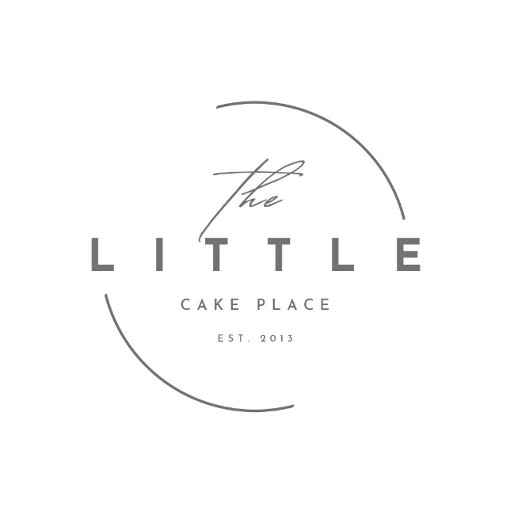

Terms and Conditions
All orders placed by you the customer is subject to our terms and conditions unless it is in writing and signed by both you and the little cake place.
Orders;
- You will be given a collection time for your order please do stick with the time given.
- No order will be booked in with out a non-refundable deposit.
- If we have been discussing an order but no deposit has been paid the order will NOT be booked in.
Deposits/ cancellations
- All deposits are non- refundable.
- We take at least a 40% deposit on all orders; the remaining can be paid on collection or a few days before hand if we are delivering.
- A cancellation fee of 20% will be charged to any customer who cancels before one month of the order. After that if you cancel with in one month of your order you will lose your deposit.
- If for any reason we have to cancel your order (very unlikely) we will of course refund you 100% of your order. This may only happen under unforeseen circumstances or serious illness.
When collecting/receiving your order
- Once you have signed for your cake order to say you are happy with it and agreed to terms and conditions it is your responsibility, we will not be liable to any damages made after it leaves us.
- Please be aware hot weather can affect how long your cake lasts and travels. Please bare this in mind when collection and storing.
- All of our cakes are made to order , they don’t have a shelf life and so you should be aware of this when you collect your cake. Store it correctly and consume within 3 days for its best before.

Allergies
- Allergies – all our cakes are baked and decorated in an environment that uses/may use wheat/dairy/nuts/soya/gluten/seeds-sulphur dioxide/milk/eggs therefore we can not 100% guarantee no traces. If we agree to bake a dairy free cake for example you will be asked to sign a form that states although we have not used dairy in your cake, it is baked in a kitchen that uses dairy. So, you (customer) will be aware of this.
- it is the responsibility of the customer to let us know of any allergies prior to the confirmation of their booking

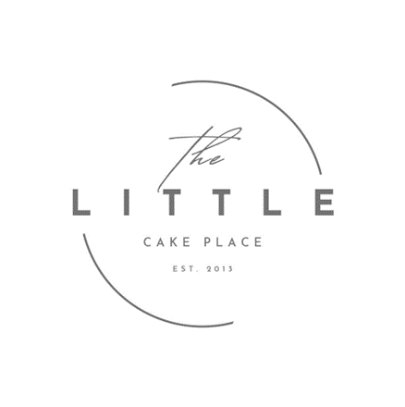
many thanks The little cake place

